
Name___________________________

Maths Specialist - Investigation

Matrix Transformations

Investigation Part 2: Validation Test

Time: 45 minutes Marks_______/44

The points $A, B, C$ and $D$ are represented by the matrix $\left[\begin{matrix}0 & 2 & 1 \\ 2 & 2 & 1\end{matrix} \begin{matrix}0 \\ 1\end{matrix}\right]$.

[6 marks]
  - Show how to transform $ABCD$ to $A’B’C’D’$ using the matrix $\left[\begin{matrix}1 & 0 \\ 0 & -1\end{matrix}\right]$.

  - On the grid below draw a labelled diagram of the quadrilaterals $ABCD$ and $A’B’C’D’$.

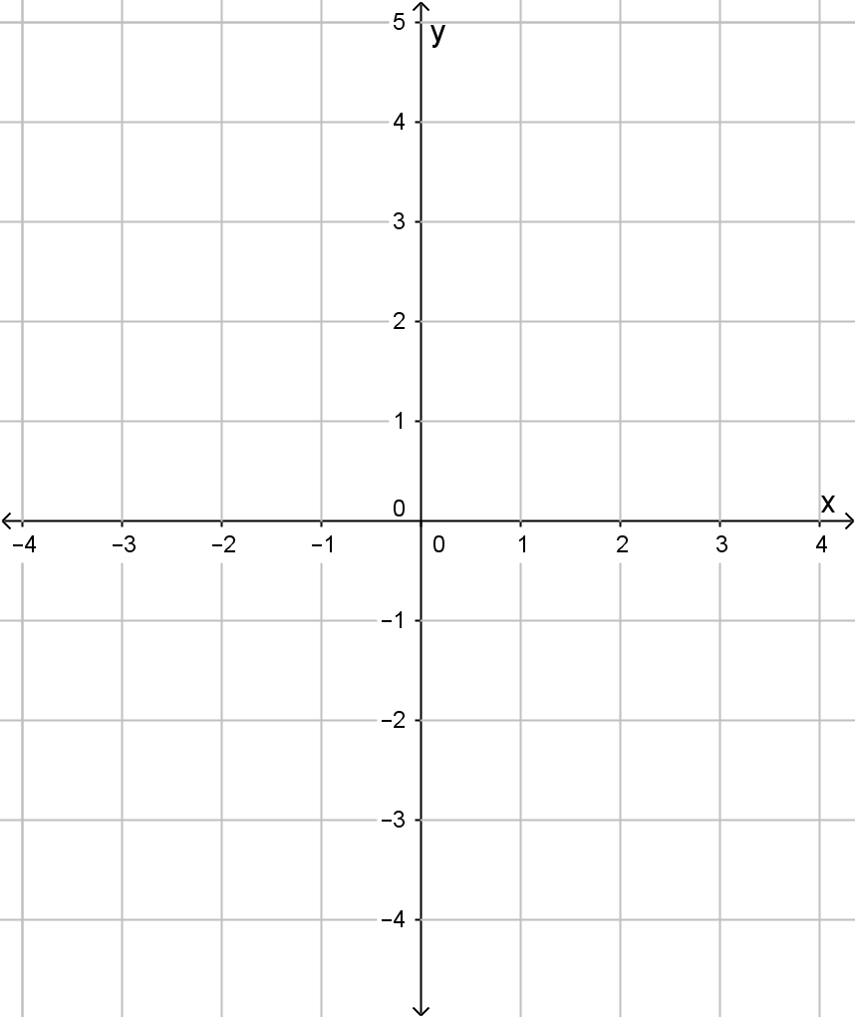

  - Describe the transformation.

[6 marks]
  - Show how to transform $ABCD$ to $A’B’C’D’$ using the matrix $\left[\begin{matrix}0 & 1 \\ -1 & 0\end{matrix}\right]$.

  - On the grid below draw a labelled diagram of the quadrilaterals $ABCD$ and $A’B’C’D’$.


c) Describe the transformation.

[6 marks]
  - Show how to transform $ABCD$ to $A’B’C’D’$ using the matrix $\left[\begin{matrix}1 & 0 \\ 0 & 2\end{matrix}\right]$.

  - On the grid below draw a labelled diagram of the quadrilaterals $ABCD$ and $A’B’C’D’$.


c) Describe the transformation.

[4 marks]
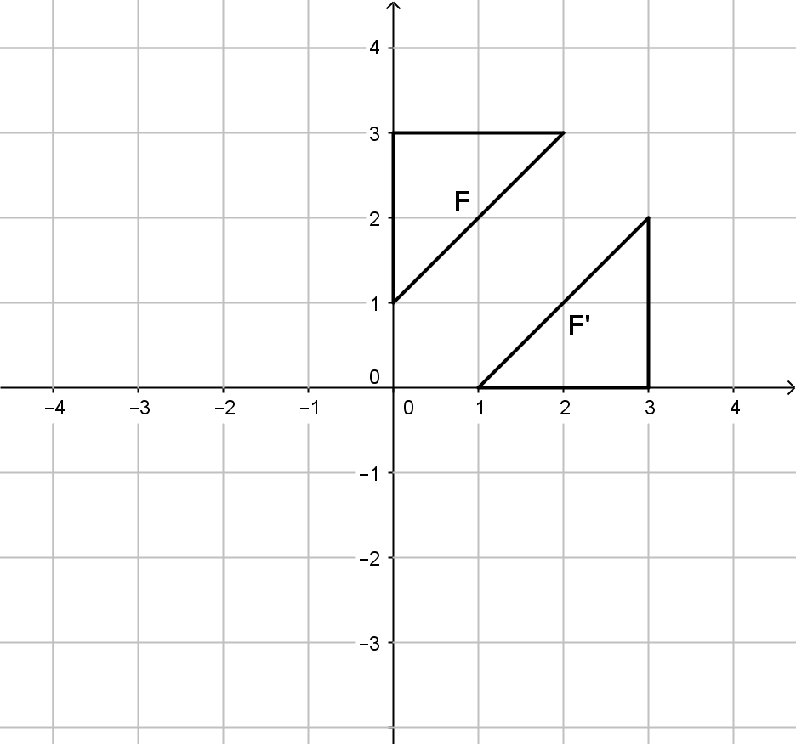
Triangle F has been transformed onto F’.
- Describe the transformation.

- Which matrix would produce this transformation?

[4 marks]
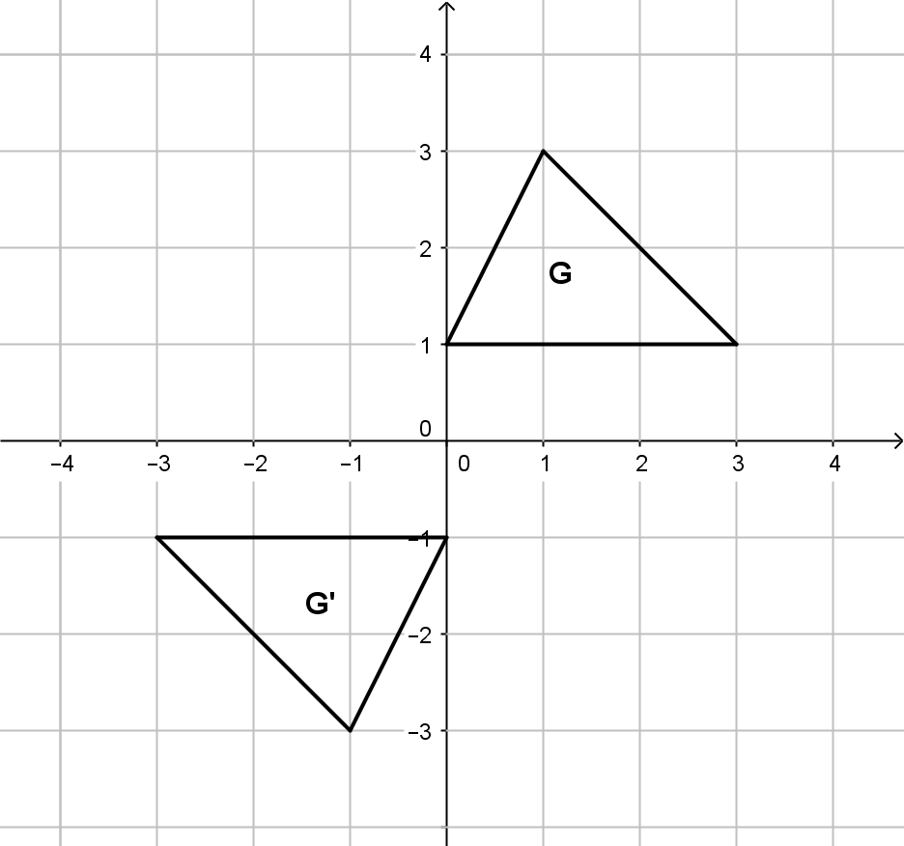
Triangle G has been transformed onto G’.
- Describe the transformation.

- Which matrix would produce this transformation?

- Triangle $ABC$ to transformed on to triangle $A’B’C’$ by the matrix $\left[\begin{matrix}2 & 0 \\ 0 & 2\end{matrix}\right]$. [4 marks]
  - Describe the transformation.

  - If the area of triangle $ABC$ is 3 square units. What is the area of triangle $A’B’C’$? Justify your answer.

- Triangle $EFG$ to transformed on to triangle $E’F’G’$ by the matrix $\left[\begin{matrix}5 & 0 \\ 0 & 1\end{matrix}\right]$. [4 marks]
  - Describe the transformation.

  - If the area of triangle $EFG$ is 6 square units. What is the area of triangle $E’F’G’$? Justify your answer.

- Triangle $PQR$ to transformed on to triangle $P’Q’R’$ by the matrix $\left[\begin{matrix}3 & 0 \\ 0 & 4\end{matrix}\right]$. [5 marks]
  - Describe the transformation.

  - How would the area of triangle $P’Q’R’$ compare with the area of triangle PQR? Justify your answer.

- Matrix A is a $2×2$ matrix and transforms $\left[\begin{matrix}0 & 1 \\ 1 & 0\end{matrix} \begin{matrix}3 \\ 2\end{matrix} \begin{matrix}2 \\ 3\end{matrix}\right]$ to $\left[\begin{matrix}-2 & 1 \\ 3 & -2\end{matrix} \begin{matrix}-1 \\ 0\end{matrix} \begin{matrix}-4 \\ 5\end{matrix}\right]$. Find matrix A.
[5 marks]

